Compute & Microservices Deployment
Azure Compute & Microservices Deployment is about hosting, scaling, managing, & operating applications composed of independently deployable services. Azure provides multiple compute options that range from fully managed platform services to container orchestration platforms, enables organizations to choose the right balance between simplicity, flexibility, control & scalability.
Microservices architectures typically divide an application into smaller atomic services that can be built, deployed, scaled, maintained independently. Azure supports these architectures through services such as Azure App Service, Azure Container Apps, Azure Kubernetes Service (AKS), Azure Container Registry, & integration with DevOps & CI/CD pipelines.
- Azure App Services vs Container Apps
Both Azure App Service & Azure Container Apps are managed Azure Compute services, but they target different deployment models & operational requirements.
Azure App Service
Azure App Service is a fully managed PaaS offering designed for hosting web applications, REST APIs, & backend services without managing underlying infrastructure.
Core Characteristics
- Full managed hosting environment
- Supports multiple programming languages & frameworks.
- Built-in operating system management.
- Integrated scaling capabilities.
- Native deployment support from GitHub Actions, Azure DevOps, & other CI/CD tools.
- Managed SSL certificates & custom domains.
- Built-in monitoring & diagnostics.
Architecture
The platform abstracts infrastructure concerns like:
- VM management
- OS patching
- Runtime installation
- Load balancing
- High availability
Scaling Model
- Vertical Scaling
- Horizontal Scaling
Deployment Options
- Source code deployment
- ZIP Packages
- Git Repos
- Docker Containers
- CI/CD Pipelines
Azure Container Apps
Azure Container Apps is a serverless container platform designed specifically for modern microservices & containerized workloads.
It abstracts Kubernetes complexity while retaining container-based deployment benefits.
Core Characteristics
    - Container-First platform
    - Serverless execution model
    - Event-driven scaling
    - Microservice focused
    - Kubernetes-powered backend
    - No cluster management required
Architecture
Container Apps runs on managed Kubernetes infrastructure, but cluster components remain hidden from users.
Developers interact with:
    - Containers
    - Revisions
    - Scaling rules
    - Networking policies
Without directly managing nodes or clusters.
Scaling Capabilities
Container apps use dynamic scaling.
Scaling can occur based on:
    - HTTP Requests
    - Queue Messages
    - Kafka Events
    - CPU Utilization
    - Memory Utilization
    - Custom Events
Revision Management
    - Multiple revisions
    - Traffic splitting
    - Gradual rollouts
    - Blue-Green deployments
    - Canary deployments
Azure App Service vs Container Apps
Feature | Azure App Service | Azure Container Apps
Primary Purpose | Web Apps & APIs | Containerized Microservices
Infrastructure Management | Fully Managed | Fully Managed
Container Support | Supported | Native
Kubernetes Exposure | None | Hidden
Scale to Zero | No | Yes
Event-driven Scaling | Limited | Native
Microservices Focus | Moderate | Strong
Operational Complexity | Low | Low to Medium
Deployment Unit | Application | Container
Traffic Splitting | Limited | Advanced

- Intro to AKS
AKS is Microsoft’s managed Kubernetes platform for deploying, orchestrating, & scaling containerized applications.
AKS reduces the complexity of operating Kubernetes while preserving full Kubernetes functionality.

AKS Architecture
An AKS cluster consists of:
  - Control Plane
  - Node Pools
  - Pods
  - Services
  - Ingress
- Docker for APIs
- Docker Components
  - Docker Image
  - Docker Containers
  - Docker Registry
- API Container Lifecycle
  - Build Stage
  - Push Stage
  - Deploy Stage
  - Run Stage
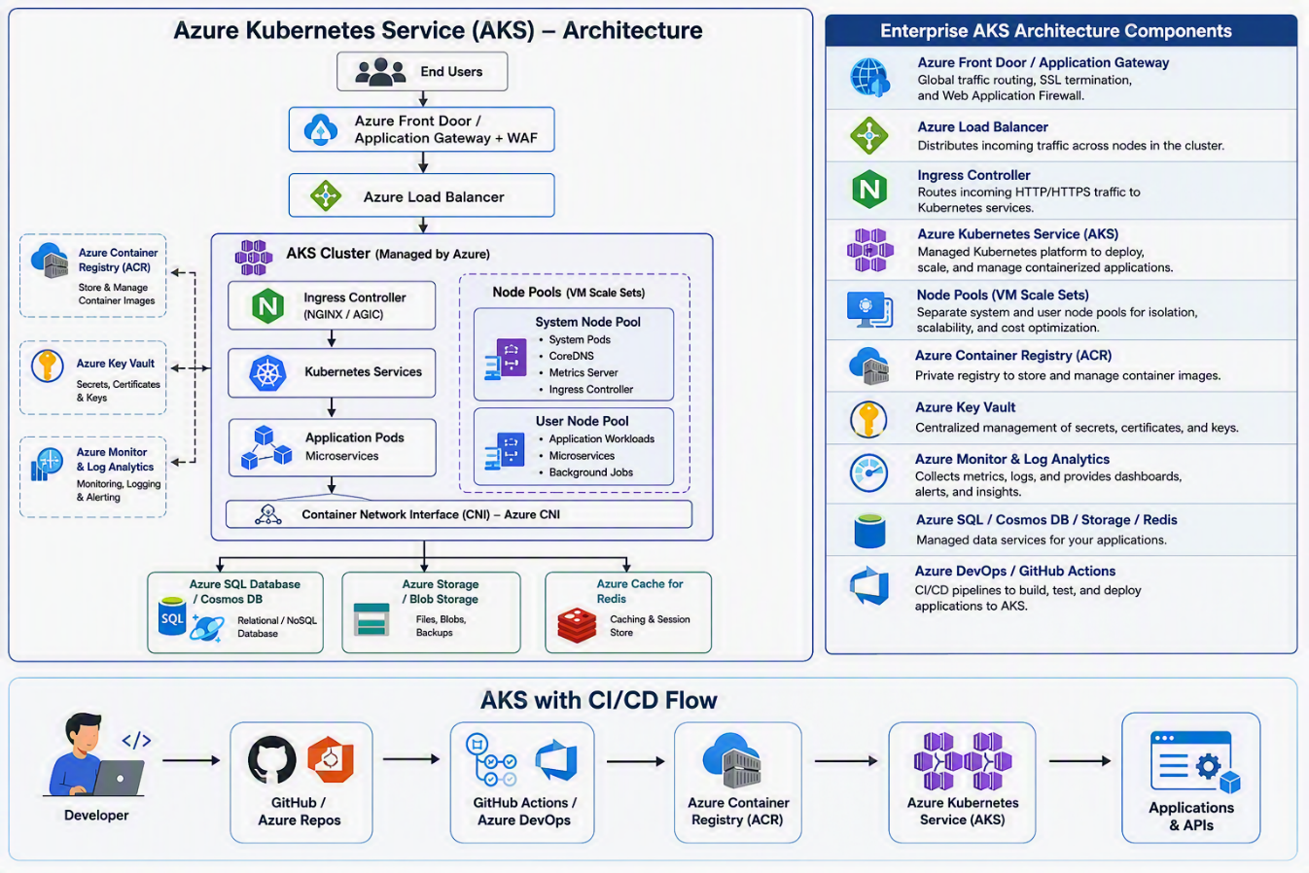

Demo:
- Containerize APIs
- Deploy to:
  - App Service
  - Container Apps

